# Question 1

$a{(a+b)}^{*}a$

${\left(b(a+b)\right)}^{*}b^{*}$

$a^{*}baaa^{*}+a^{*}abaa^{*}+a^{*}aaba^{*}+aaa^{*}$

$(a+b){(a+b)}^{*}$

# Question 2

$ϵ+a{\left(a+b\right)}^{*}+{\left(a+b\right)}^{*}aa{\left(a+b\right)}^{*}a{\left(a+b\right)}^{*}$

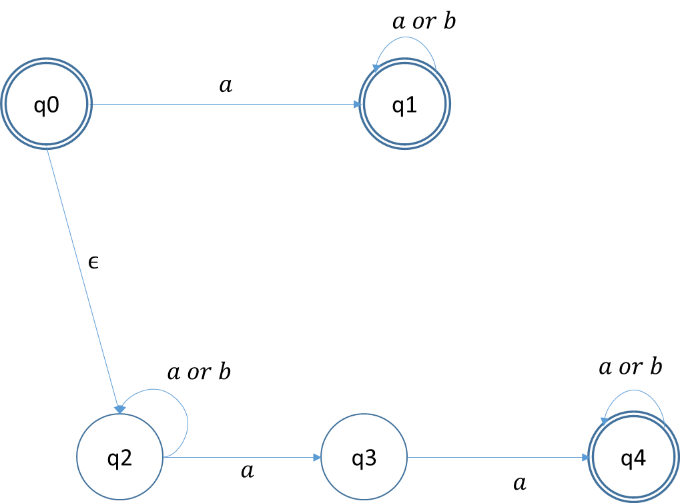



${\left[ba+\left(a+bb\right)a^{*}b\right]}^{*}$

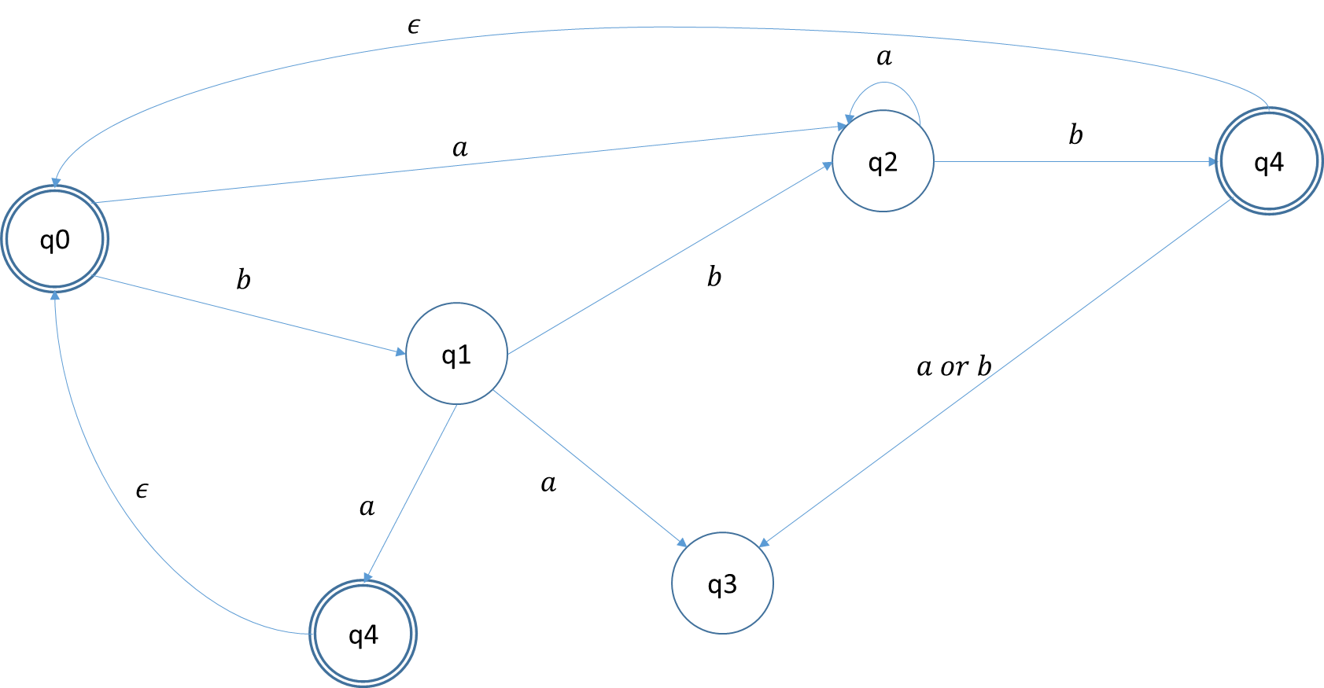

# Question 3

In fact the only condition for it to work is to satisfies this expression which correspond to having at least an $a and b$

$$Σ^{*}$$

Let take a string that satisfies the expression

Let split this string in two pieces $x and y$ with n $a$ in $x$ and $m a$ in $y$ and $n, m≥0$

If $n=m$ then we are done the string is in the set

Let suppose $n<m$

Then we can move the split of the string one letter further. If the letter is $a$ then we have $n+1 a^{'}s in x$ and still $m b^{'}s in y$, if it’s a b then we have still $n a^{'}s in x$ and $m-1{ b}^{'}s in y$ Then we check if the amount are the same now, if not then we can repeat this step until they match

Similarly with $n>m$ we move the split left

Then this expression define this language and thus it’s a regular language.

# Question 4

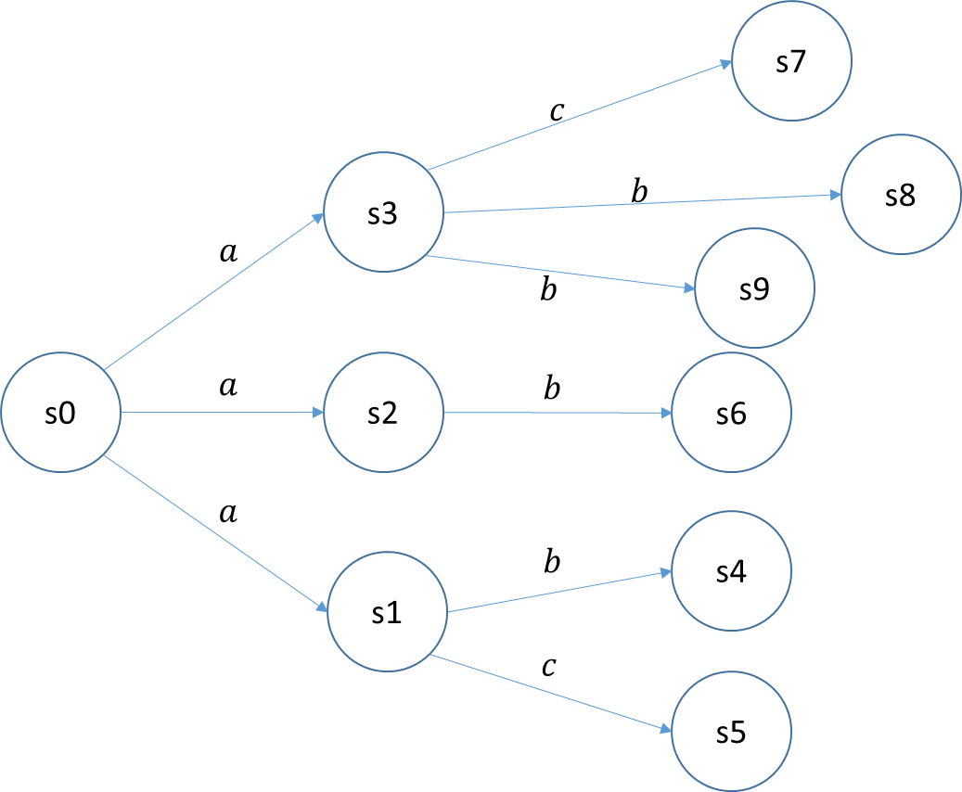

We see that $s_{1}$ and $s_{3}$ are bisimilar as we have the same outgoing transition (b and c)

We also have $s_{4}$ to $s_{9}$ bisimilar as they don’t have any outgoing transitions

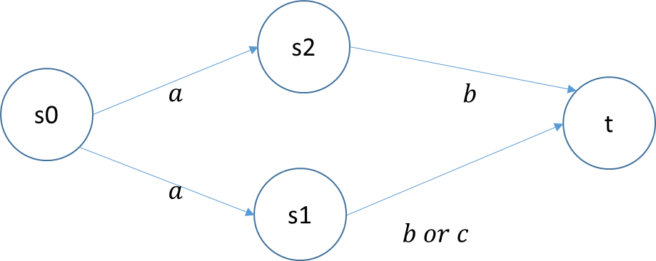

# Question 5

|  |  |  |  |  |  |
| --- | --- | --- | --- | --- | --- |
|  | $$ϵ$$ | $$a$$ | $$b$$ | $$aa$$ | $$bb$$ |
| $$ϵ$$ | Eq |  |  |  |  |
| $$a$$ |  | Eq |  |  |  |
| $$b$$ |  |  | Eq |  |  |
| $$aa$$ |  |  |  | Eq |  |
| $$bb$$ |  |  | Eqq |  | Eq |

Nothing starts with b that is in $L$. All equivalent classes on $a$ are equivalent to themselves. $ax$ is equivalent to $ax$ for any $x$.

The only equivalent classes in $L$ are on $a^{*}$

Because $a^{n}, n∈N$ there are infinite equivalence classes as there is an equivalent classes for each $a^{n}$ where $n∈N$, $N$ is distinct from itself